Name ___________________________ Class ___________________ Date _____________

Chapter 11 Motion

Section 11.3 Acceleration

(pages 342–348)

This section describes the relationships among speed, velocity, and acceleration. Examples of these concepts are discussed. Sample calculations of acceleration and graphs representing accelerated motion are presented.

Reading Strategy (page 342)

Summarizing Read the section on acceleration. Then complete the concept map to organize what you know about acceleration. For more information on this Reading Strategy, see the Reading and Study Skills in the Skills and Reference Handbook at the end of your textbook.

 |  |  |  |  | Acceleration
 | is a change |  |  |  |  |  |  | is measured
 |  | in |  |  |  |  |  | in units of

© Pearson Education, Inc., publishing as Pearson Prentice Hall. All rights reserved.

What Is Acceleration? (pages 342–345)

1. The rate at which velocity changes is called .

- In terms of speed and direction, in what ways can an object accelerate?

- Because acceleration is a quantity that has both magnitude and

direction, it is a(n) .

- Is the following sentence true or false? Acceleration is the result of increases or decreases in speed.

- Ignoring air resistance, a rock in free fall will have a velocity of

after 4.0 seconds.

- A horse on a carousel that is moving at a constant speed is

accelerating because .

- Describe constant acceleration.

Calculating Acceleration (pages 345–346)

- Write the equation used to calculate the acceleration of an object.

Physical Science Guided Reading and Study Workbook ■ Chapter 11 99

Name ___________________________ Class ___________________ Date _____________

Chapter 11 Motion

- Is the following sentence true or false? When the final velocity is less than the initial velocity of an object, the acceleration is negative.

- A skateboarder begins down a ramp at a speed of 1.0 m/s. After 3 seconds, her speed has increased to 4.0 m/s. Calculate

her acceleration.

a. 1.0 m/s² b. 3.0 m/s²
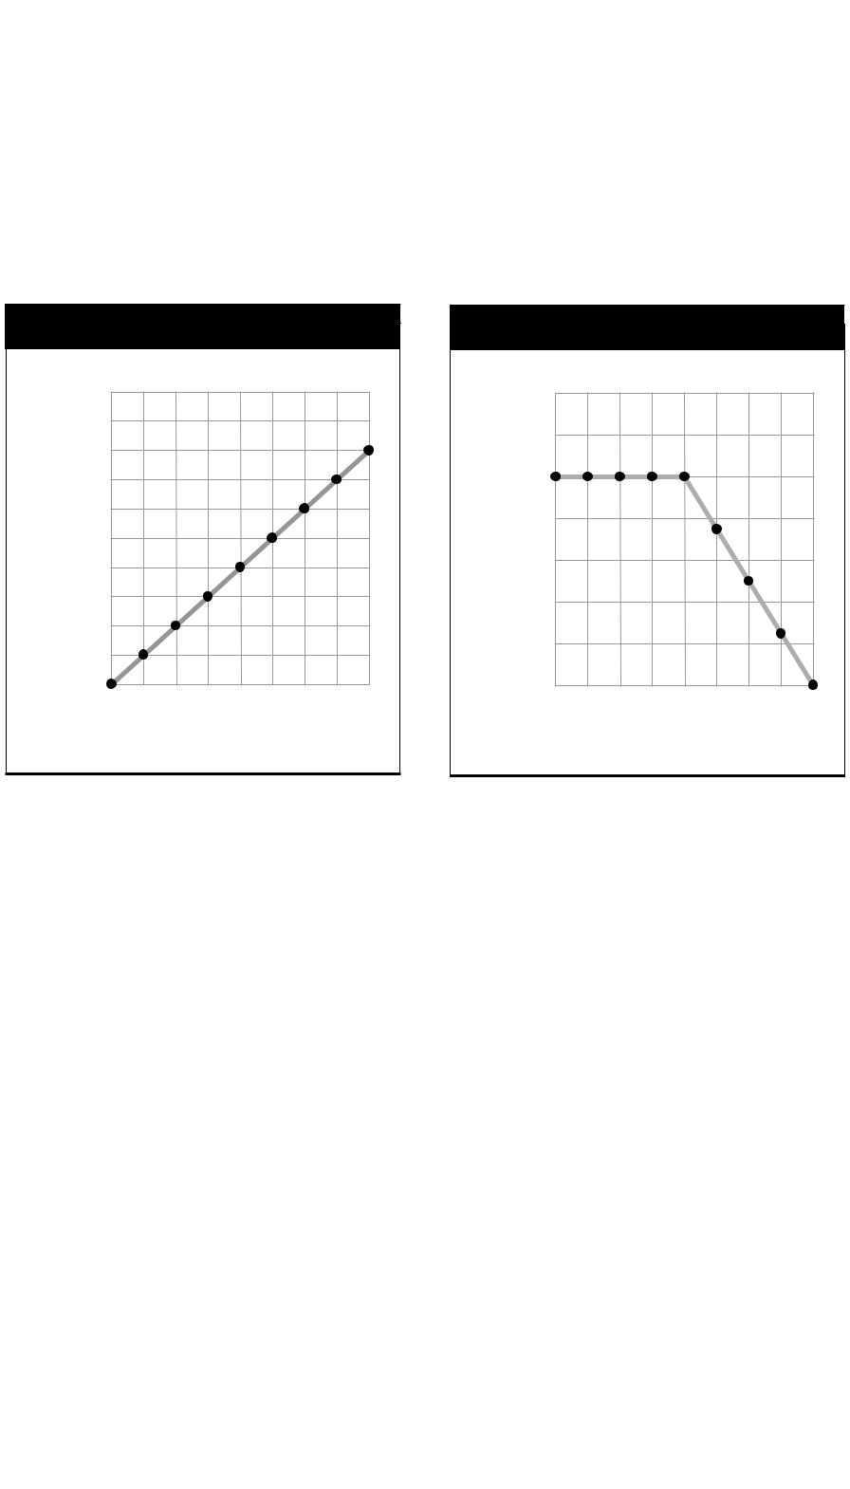
c. 5.0 m/s² d. 9.8 m/s²

Graphs of Accelerated Motion (pages 346–348)

- A speed-time graph in which the displayed data forms a straight

line is an example of a(n) .

For questions 12 through 15, refer to the graphs below.

Speed (m/s)

Acceleration Graph A

20
16
12
8
4
0 | 1 | 2 | 3 | 4
0

Time (s)

Acceleration Graph B

 | 7
 | 6
(m/s) | 5
 | 4
Speed
 | 2
 | 3

1
0 | 5 | 10 | 15 | 20
0

Time (s)

© Pearson Education,

- Graph A represents the motion of a downhill skier. How fast was the skier moving after traveling down the hill for 2.5 seconds?

- In which graph does an object move at constant speed during the first 4 seconds?

- Graph B represents the motion of a mountain biker. What is the biker’s speed at times of 10 s and 20 s?

- Determine the acceleration of the mountain biker during the 10 second to 20 second time period. Show your work.

- The plotted data points representing acceleration in a distance-time
graph form a(n) .

Instantaneous Acceleration (page 348)

- The measure of how fast a velocity is changing at a specific instant

is known as .

Inc., publishing as Pearson Prentice Hall. All rights reserved.

100 Physical Science Guided Reading and Study Workbook ■ Chapter 11

