Practice Reading Velocity vs. Time Graphs

 |  | Graph 1 | Graph 2
1. What is plotted on the x-axis? What are the units?
2. | What is plotted on the y-axis? What are the units?
3. | How much is each division on the x-axis?
4. | How much is each division on the y-axis?
5. | What is the Independent Variable?
6. | What is the Dependent Variable?
7. | What is the initial velocity (vinitial)?
8. | What is the final velocity (vfinal)?
9. | During what time interval is the velocity the highest?
10. | What is the highest velocity on the graph?
11. | During what time intervals is the person not moving?
12. | During what times is the person speeding up?
13. | During what times is the person slowing down?
14. | During what time intervals does the person move with a
 | constant velocity?
15. | What is the acceleration of the person from A-B?
16. | What is the acceleration of the person from B-C?
17. | What is the acceleration of the person from C-D?
18. | What is the acceleration of the person from D-E?
19. | What is the acceleration of the person from E-F?

Graph 1 |  |  |  |  |  |  |  |  | Graph 2
 | 40 |  |  |  |  | Velocity vs time |  |  |  | 350 |  | Velocity vs time
 | 30 |  |  |  |  |  |  |  |  | 300
 |  |  |  |  |  |  |  |  |  | 250
Velocity (m/s) | 20 |  |  |  |  |  |  |  | Velocity (km/hr) | 200
 | 10 |  |  |  |  |  |  |  |  | 150
 |  |  |  |  |  |  |  |  |  | 100
 | 0 |  |  |  |  |  |  |  |  | 50
 | -10 | 0 | 20 | 40 | 60 | 80 | 100 | 120 |  | 0
 | -20 |  |  |  |  |  |  |  |  | -50 | 0 | 5 | 10 | 15
 |  |  |  |  |  |  |  |  |  | -100
 | -30 |  |  |  | Time (sec) |  |  |  |  | -150 |  | Time (hr)
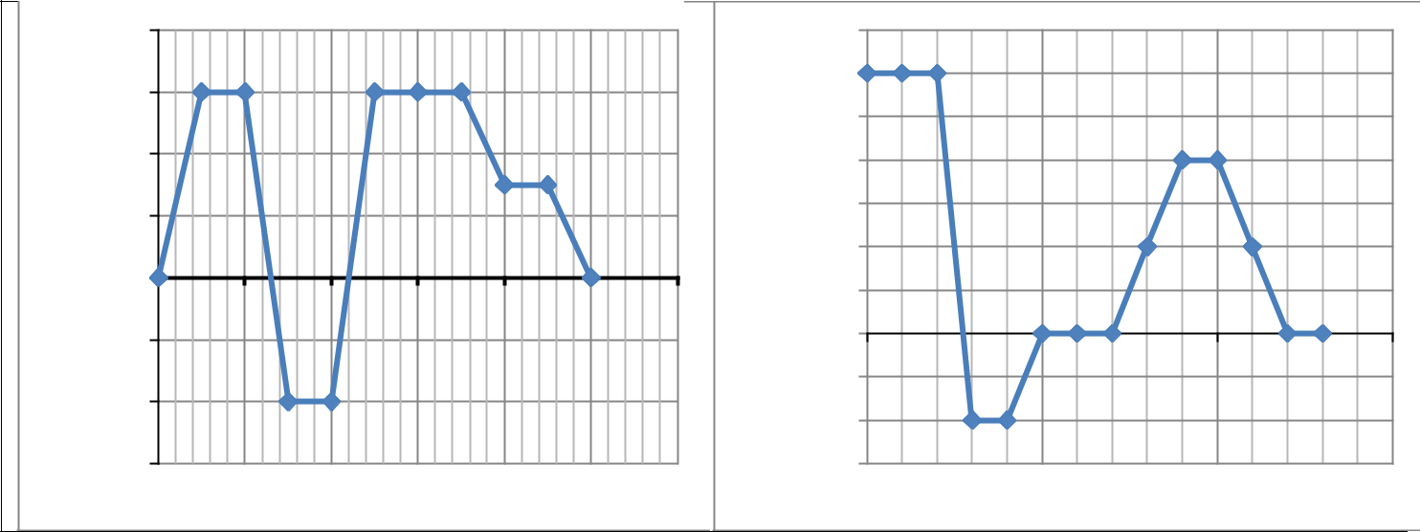

 |  | Graph 1 | Graph 2
1. What is plotted on the x-axis? What are the units?
2. | What is plotted on the y-axis? What are the units?
3. | How much is each division on the x-axis?
4. | How much is each division on the y-axis?
5. | What is the Independent Variable?
6. | What is the Dependent Variable?
7. | What is the initial velocity (vinitial)?
8. | What is the final velocity (vfinal)?
9. | During what time interval is the velocity the highest?
10. | What is the highest velocity on the graph?
11. | During what time intervals is the person not moving?
12. | During what times is the person speeding up?
13. | During what times is the person slowing down?
14. | During what time intervals does the person move with a
 | constant velocity?
15. What is the acceleration of the person from A-B?
16. What is the acceleration of the person from B-C?
17. What is the acceleration of the person from C-D?
18. What is the acceleration of the person from D-E?
19. What is the acceleration of the person from E-F?

Graph 3 |  |  |  |  |  | Graph 4
 | 800 |  |  | Velocity vs time |  |  | 50 |  |  | Velocity vs time
 |  |  |  |  |  |  | 40
 | 600
 |  |  |  |  |  |  | 30
(m/min) | 400 |  |  |  |  | (m/sec) | 20
 |  |  |  |  |  |  | 10
 | 200 |  |  |  |  |  | 0
Velocity | 0 |  |  |  |  | Velocity | -10 | 0 | 50 | 100 | 150 | 200
 |  | 0 | 500 | 1000 | 1500 |  | -20
 | -200
 |  |  |  |  |  |  | -30
 | -400 |  |  |  |  |  | -40
 |  |  |  |  |  |  | -50
 | -600 |  |  | Time (min) |  |  | -60 |  |  | time (s)
